Brief
West Highland College requires UHI a new website.
You have been asked to start a new site from scratch and to keep the same logo and colour scheme.
The website will aim to bring news and information to new and returning students.
You may wish to highlight Courses, Activities and Facilities.
This site must include at least 4 pages that connect to each other.

Outcome 2
Plan and design a website to meet a given brief.
Performance Criteria
- Produce a requirements list from the brief.
Target Audience – Goals/Requirements
(b) Produce an outline design for the website.
https://wireframe.cc/
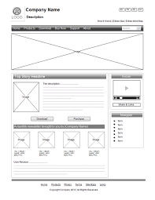

(c) Create a navigational structure for the website.
https://www.draw.io/

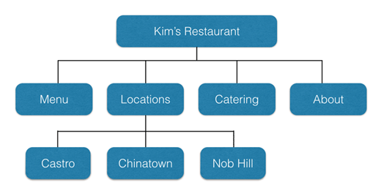
(d) Produce a resources list.
Software – Hardware – Media Resources

Outcome 3
Produce a website from the design specification using appropriate software tools.
Performance Criteria
(a) Produce a template web page that will provide consistent layout and formatting throughout the website.
(b) Produce the completed website using the template.

Outcome 4
Upload and test the website.
Performance Criteria
- Upload the website to a server.
https://neocities.org/
(b) Produce a test plan.
(c) Implement the test plan for the website.
(d) Log the test results and resolve any identified errors.
