Brief
You have been approached by a music video producer.
He represents a well-known artist. He requires backdrops for their upcoming music video.
They are interested in the natural beauty of your surrounding area.
You must submit a portfolio of at least 10 images to choose from.
Care should be given to ensure all images meet the technical requirements for a 1080p video output.

Guidance
You should use a combination of Screenshots and written work to present your work in an organised format which could be presented to a client.
You should be specific about you plans, intentions, actions, obstacles, risks and your performance.
You Should keep a log of all activity.
You must ensure that your finished work meets all criteria below, it is a good idea to start at the top and work your way down.

OUTCOME 1
Identify and plan the acquisition of digital still images to meet the requirements of the brief. Performance Criteria
- State the requirements of the specified brief in terms of its image requirements, technical standards and time constraints.
- Identify copyright requirements for all images.
- Plan a schedule for image acquisition to the standards and time constraints of the brief.
Be specific about locations and intent
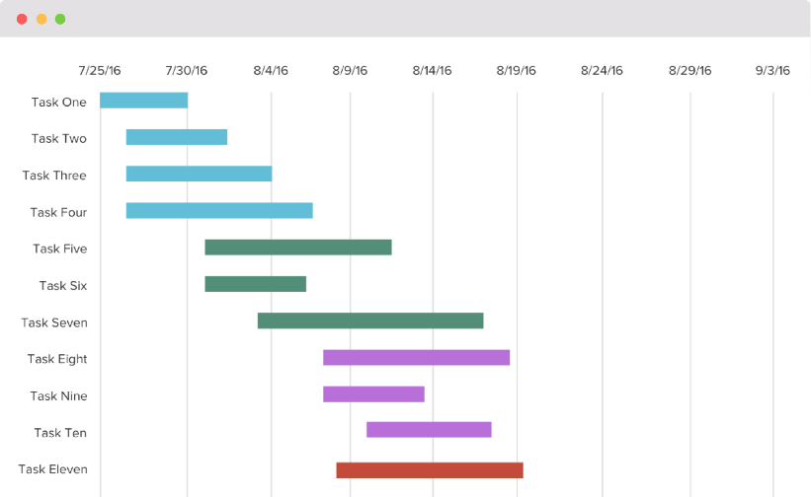
This is an example of a Gantt Chart – something similar could be achieved in excel

- Produce an assessment of risks for the planned schedule of acquisition activities.
Risk Assessment – Risk Reduction – List of Hazards

OUTCOME 2
Undertake the acquisition of digital still images for a specified brief.
Performance Criteria
(a) Acquire images which conform to the technical standards of the brief within the specified timescale.
(b) Label and store the acquired images to enable efficient identification and retrieval.
Useful Names – Organised Folders
(c) Complete identified copyright requirements.
(d) Conduct activities in a manner consistent with identified risks.

OUTCOME 3
Select, edit and present a portfolio of digital images in a format appropriate to a specified brief. Performance Criteria
(a) Select images which are appropriate to the requirements of the specified brief.
(b) Edit the selected images to meet the requirements of the specified brief.
(c) Provide the statement of copyright for each selected image.
Include release forms for people
(d) Present images in a portfolio in the format required by the specified brief

OUTCOME 4
Evaluate the completed portfolio of digital images and personal contribution to meeting a specified brief.
Performance Criteria
(a) Document problems encountered and any strategy employed to resolve them.
(b) Justify the selection of images for the portfolio with reference to the requirements of the specified brief.
I have chosen this image because…
(c) Evaluate the completed portfolio against the requirements of the brief.
(d) Evaluate personal contribution to the production of the portfolio.
Minimum 500 words
How well do you think your final presentation meets the requirements of the brief?
Why did you choose the images contained in the presentation?
What problems did you encounter while completing the tasks and how did you resolve them?
How well do you think you performed during the project and what would you do differently if you could do it again?

