Audio Editing
In the Brief I have been asked to produce a 30 second podcast where I can talk about technology. I need to advertise the company OCP and need to be careful to use the wording….””. ~The finished product must be rendered in FLAC with compression

Topic
My topic of conversation for my podcast will beTop 10 Youtube videos. I will write a list and a rough script to help me when I record.

Expected files
My voice talking.wav - 48khz uncompressed wav
Explosion Sound Effect - at least 128kpbs mp3
Advert jingle - Happy music minumum 128kpbs mp3 – youtube audio library www.asdfasd.com
OCP advert my voice.wav - - 48khz uncompressed wav

Copyright
Explosion sound effect downloaded from----- attributed to
Music from Sony records

Schedule
 | Week 1 | Week 2 | Week 3
Read the Brief
Decide Topic
Expected File
List
Script
Record
Edit
Mix
Render

Resources
Hardware
Microsoft Life Cam Webcam
Sony Headphones
Software
Reaper
Word
Excel

Script
10. Breath of fire 3
9. Street Fighter II
8. Wip3Out
7. Dragon Quest 9
6. Final Fantasy 7
5 Ridge Racer PSP
.4 Megaman 9
.3 Duke Nukem forever
2. Manhunt 2
1.RAMBO the videogame

Actual Filenames
Explosion.mp3
Crunk.mp3
Voice.wav

Edits Made
I cut the start of the music and added reveb to make it sound great

Screen Shot
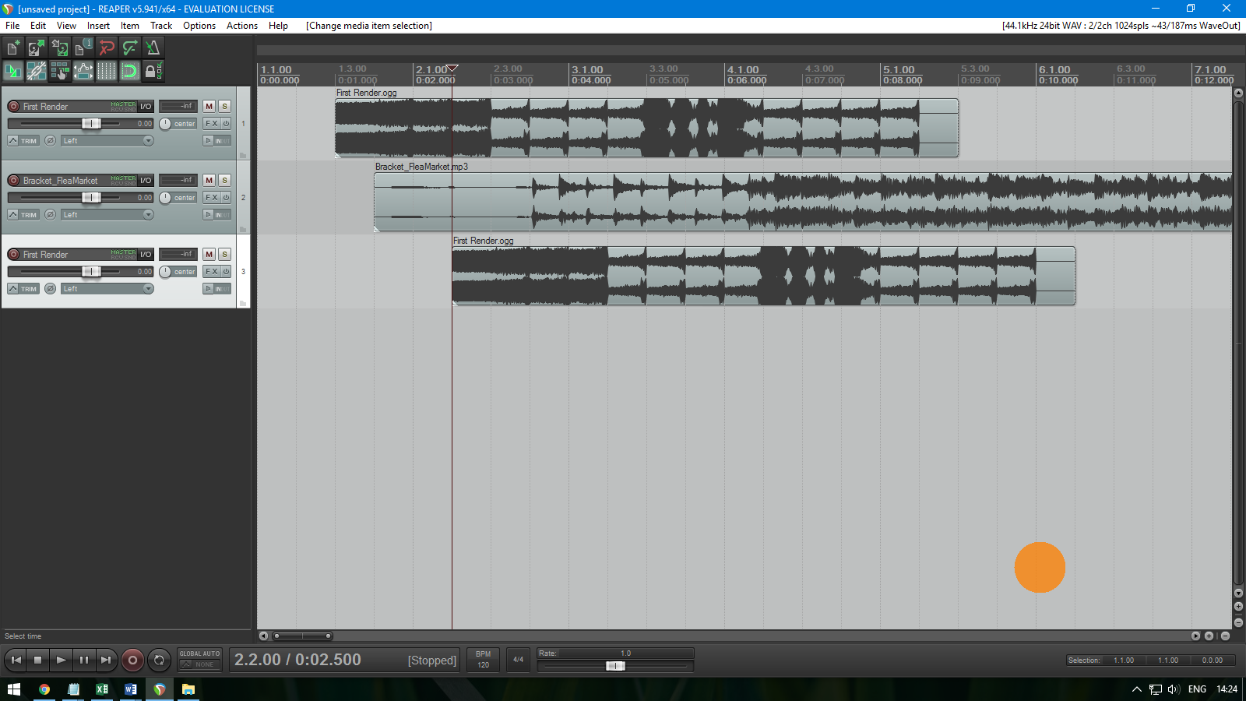

Finished File Name
OCP Podcast.flac

Evaluation
I did a good job… 150 words

